**Guidelines for Data Visualization and Analysis Project**

**About the Project:**

In this project, you will be working with a dataset from the Superstore, aiming to answer 30 scenario-based questions through data visualisation and analysis. Your objective is to select the best chart for each question, explain your choice. This project will showcase your proficiency in data visualisation, critical thinking, and effective communication.

**Skills Required:**

* Proficiency in data visualisation concepts and techniques.
* Familiarity with Tableau or a similar data visualisation tool.
* Strong analytical and problem-solving skills.
* Ability to choose appropriate charts based on data characteristics and question requirements.
* Clear and concise communication skills.

**Deliverables:**

* A Google document containing solutions to the scenario based questions including the screenshot of relevant chart picked for each scenario, presented in a concise and well-structured format. Make sure to provide explanations that highlight your problem-solving skills.

**Rubrics for Assessment:**

Question Responses:

* Accuracy and completeness of answers for all 30 questions.
* Clear and concise explanations that address the question's context.

Chart Selection and Explanation:

* Thoughtful rationale for choosing specific chart types.
* Justification based on data characteristics, context, and communication goals.

Creative Enhancements:

* Effective use of creative elements to enhance visualisation quality.
* Enhancements that contribute to better understanding or engagement.

**Note**:

* Duplicate this document and proceed to write your solutions.
* For each scenario and question, provide a justification for the choice of chart type. Explain why it is the best option to visualise the data effectively.
* Attach screenshots of the charts you have created in Tableau for each scenario and question using the Superstore dataset. Label them clearly to match the corresponding questions in the Google Document.
* Submit the duplicated google doc file after completion.

Use these guidelines to structure your data visualisation and analysis project. Remember to maintain consistency in your responses, explanations, and visualisation styles. This project will not only demonstrate your skills but also your ability to effectively communicate complex information through visualisations. Good luck!

**Problem Statement: Choose the Best chart for any 30 scenario based questions from Superstore Dataset.**

Imagine you are a data enthusiast aiming to excel in data visualisation and analysis. In this task, you have been given any 30 scenario-based questions derived from the Superstore dataset, and your objective is to provide insightful answers using appropriate charts. For each question, you need to select a chart that best represents the data, explain why you chose that specific chart, and then proceed to build the chosen chart using Tableau.

Your responses should be succinct, organised, and illustrative of your problem-solving capabilities.

**Dataset Link:**

<https://community.tableau.com/s/question/0D54T00000CWeX8SAL/sample-superstore-sales-excelxls>

**Please keep in mind:**

1. **Answer Completion**: Ensure that you furnish answers for all any 30 questions and build charts for them.
2. **Encouraged Creativity**: Don't hesitate to employ visuals, creative elements, or any other innovative approaches to enhance the quality of your responses.

By completing this task effectively, you'll not only demonstrate your proficiency in data visualisation and analysis but also showcase your ability to effectively communicate complex concepts through both text and charts.

**Good luck!**

**Questions:**

1.Which product categories have the highest total sales in the "Superstore" dataset?

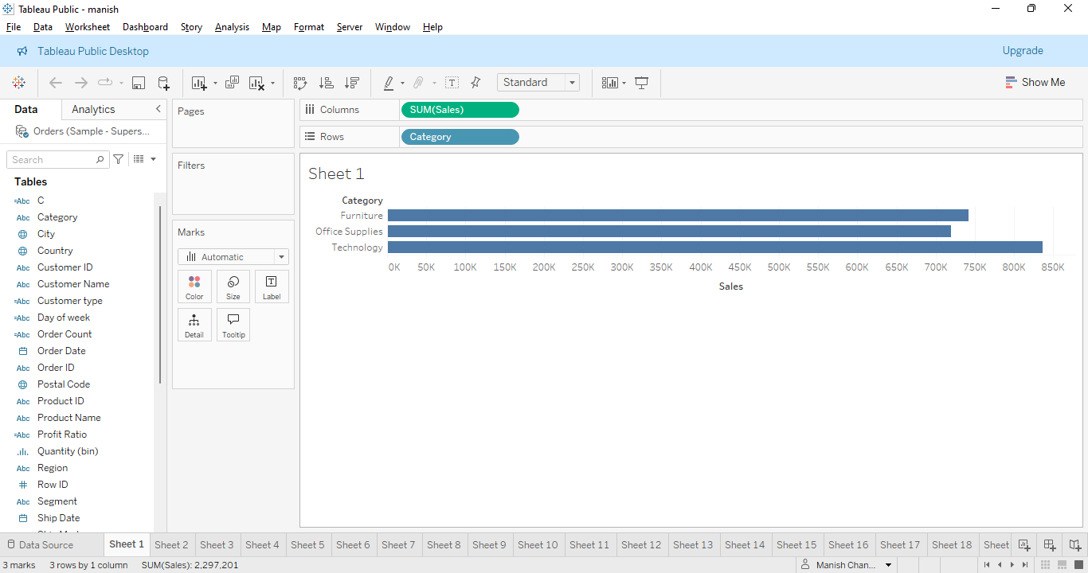

Chart type- Horizontal bar chart

Explanation-This Horizontal bar chart is easily showing the particular relation between sales and categories. We can easily see in this bar chart the distribution(highest,lowest) for the sales in terms of categories. This insight will play a significant role for the upcoming prediction.

2.How do the monthly sales amounts change over the course of a year?

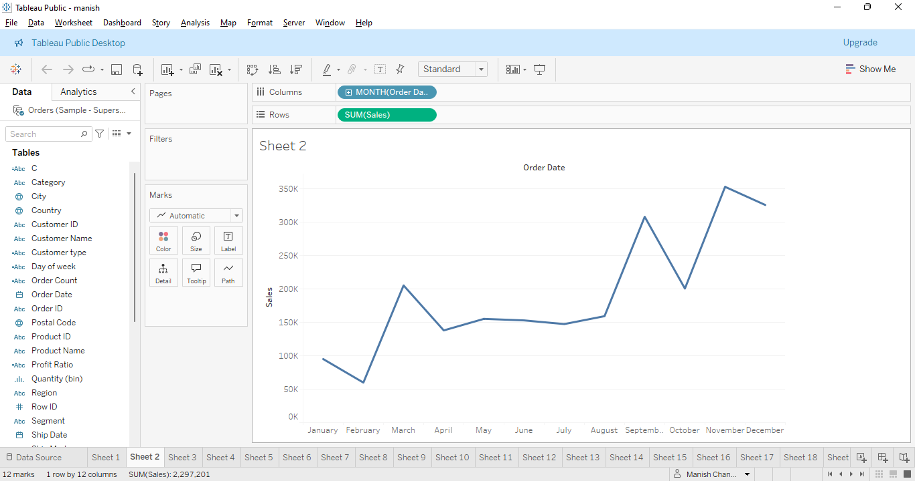

Chart type- Line Chart

Explanation- This chart is showing the monthly sales amounts change over the year.

We analyse it in terms of months. Initially trends are low but last trends show high changes as the above chart is showing. Others like bar charts can be an alternative for this. This chart plays crucial roles for getting meaningful insights. .

3.How is the total sales amount distributed among different product categories?

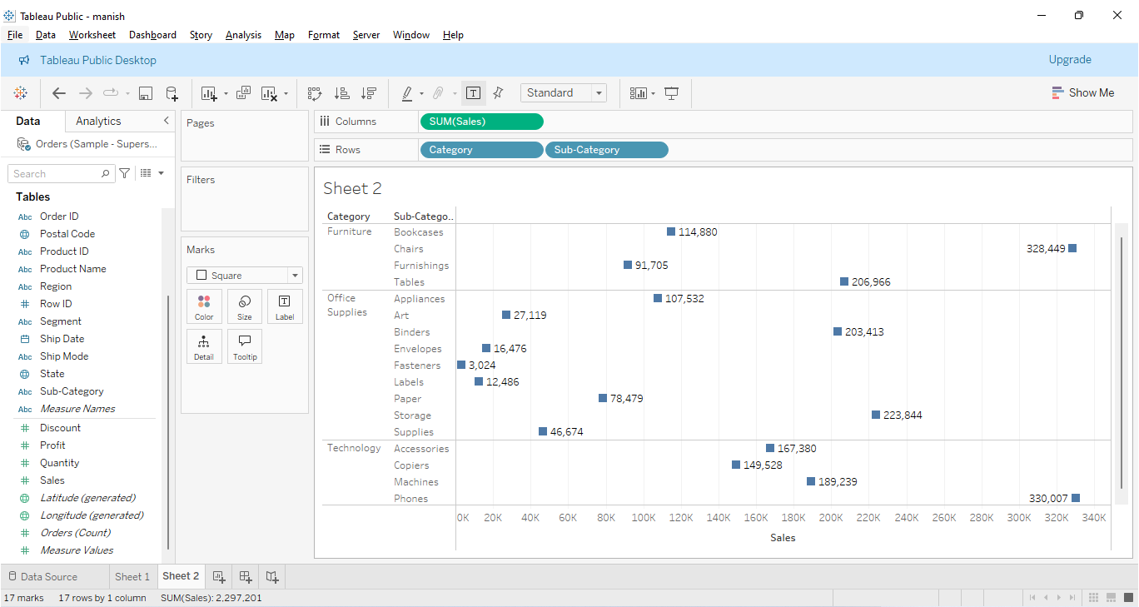

Chart type- Square chart

Explanation- this chart shows the total amount distributed among different product categories. Chart is showing the respective values to avoid unnecessary confusion and

Category and subcategory wise we can see all the insightful information for it. Bar chart can be one of the options for it but it is the best presentation for it.

4.Can we analyze the sales performance of individual customers over time?

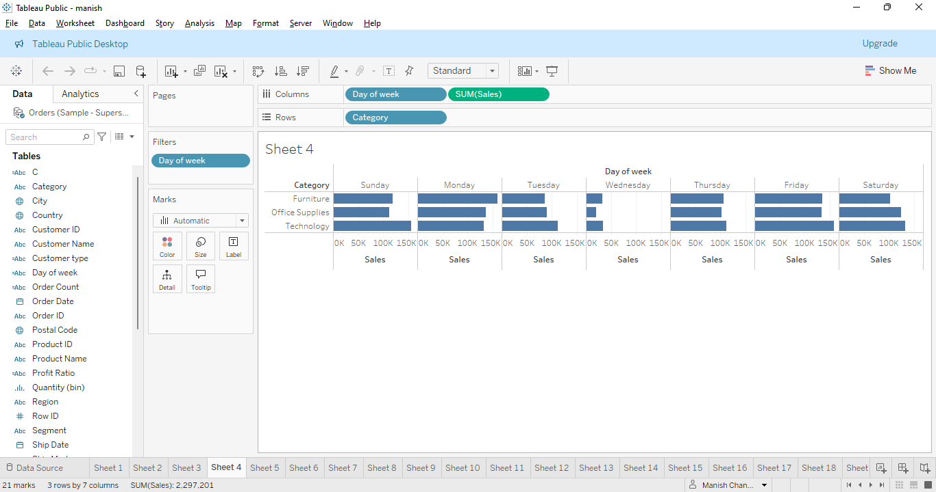

Chart type-Horizontal bar chart

Explanation- This particular Bar Chart shows the sales performance of individual customers over time. It is categorised in the chart with weeks particular days Sunday, Monday, Tuesday etc for the sales. It is the best chart to understand the data distribution. It will play the crucial role with further insights.

5.How do sales vary based on different days of the week and product categories?

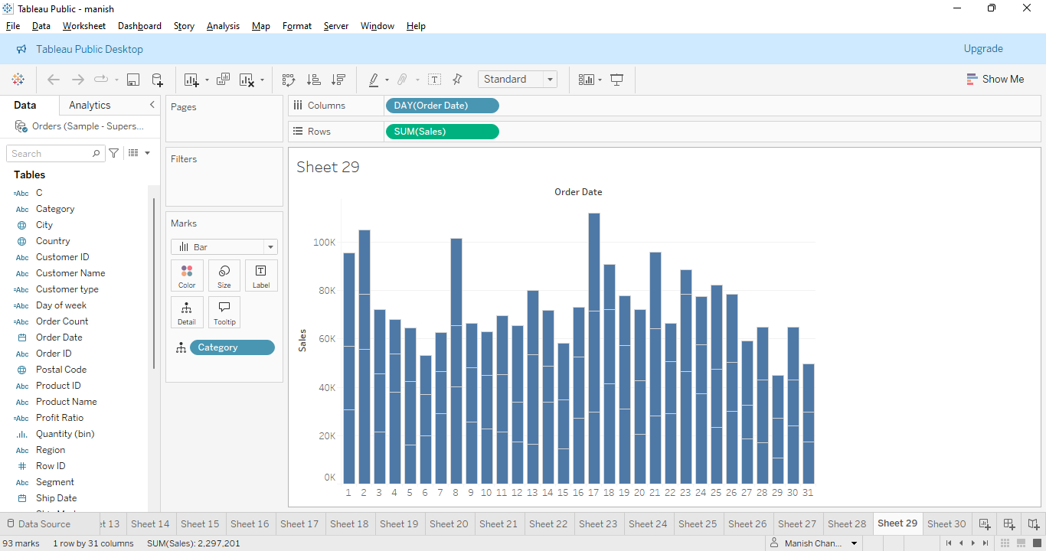

Chart type-Stacked bar chart

Explanation- This chart shows sales based on different days of the week and product categories. It enables us to view how each product category contributes to overall sales for a specific day. This can be modified in terms of weeks analysis.

6.Can we visualise the sales growth of different product categories over time?

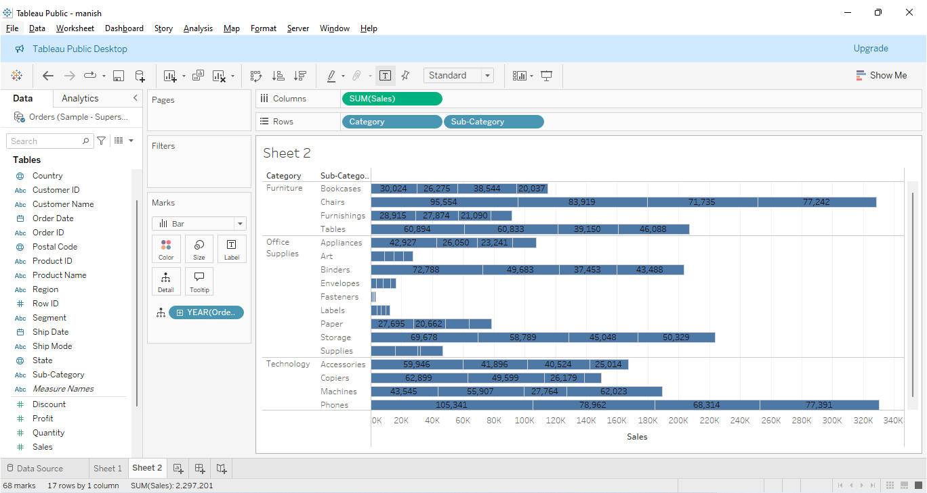

Chart type- Bar chart

Explanation- this chart shows sales growth for different product categories over time.

The bar chart shows outcomes based on year and category and subcategory wise. Values are also shown to avoid unnecessary confusion. Bar chart is the best chart for its useful visualisation and information.

7.How does the sales distribution vary across different regions in the "Superstore" dataset?

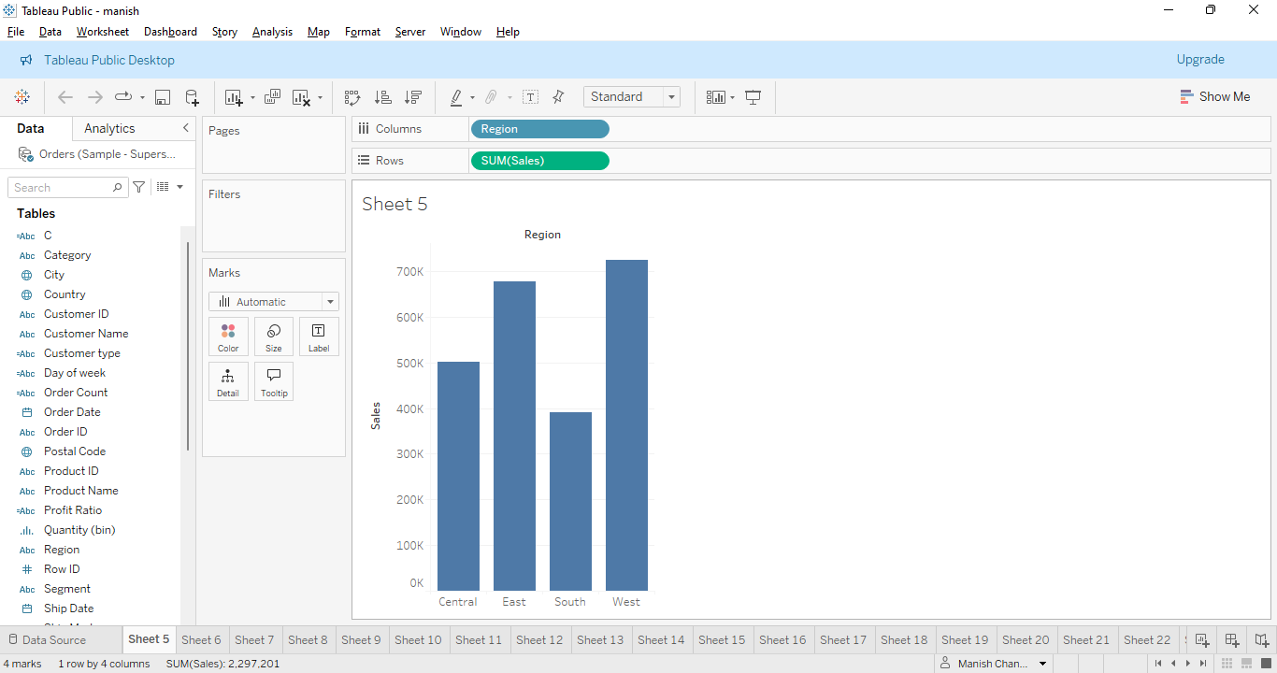

Chart type- Bar chart

Explanation- this bar chart particularly shows sales distribution in the different regions in the Superstore dataset. Regions are East,West,South,Central. West is highest and south is lowest.

Line chart or pie chart can be alternative for this chart. Chart is depicting relation between sales and regions.

8.Can we visualise the composition of profits across various subcategories within different customer segments?

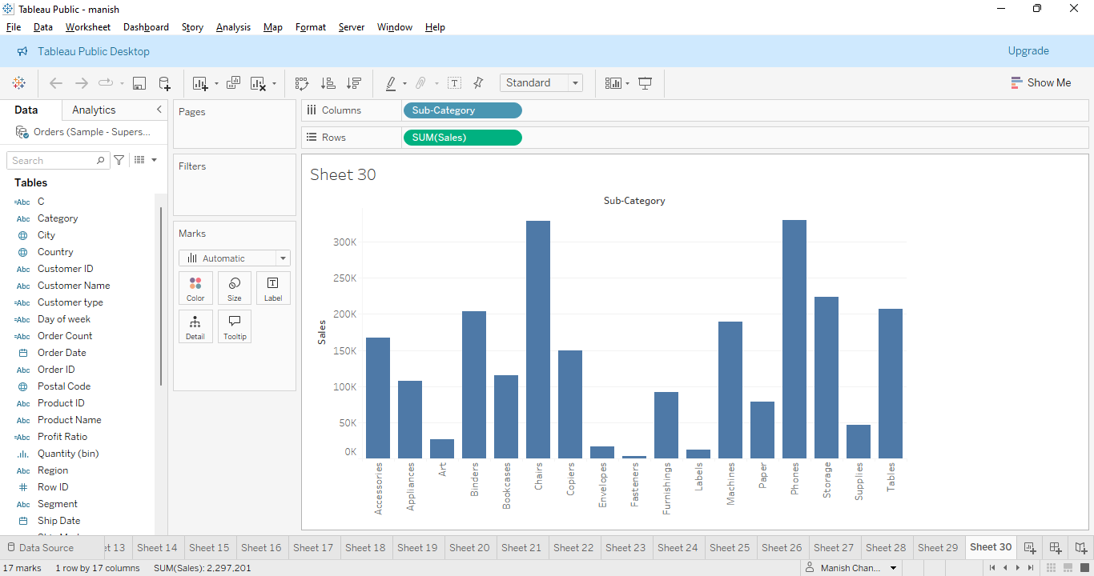

Chart type- Bar chart

Explanation- We have visualised the composition of profits across various subcategories within different customer segments. This relation is between sales and subcategories. Particular categories showing the insightful information. It is very easy to understand the

bars in this graph with respect to sales. I think this graph is categorically suitable for insights.

9.What is the percentage contribution of each region to the overall sales?

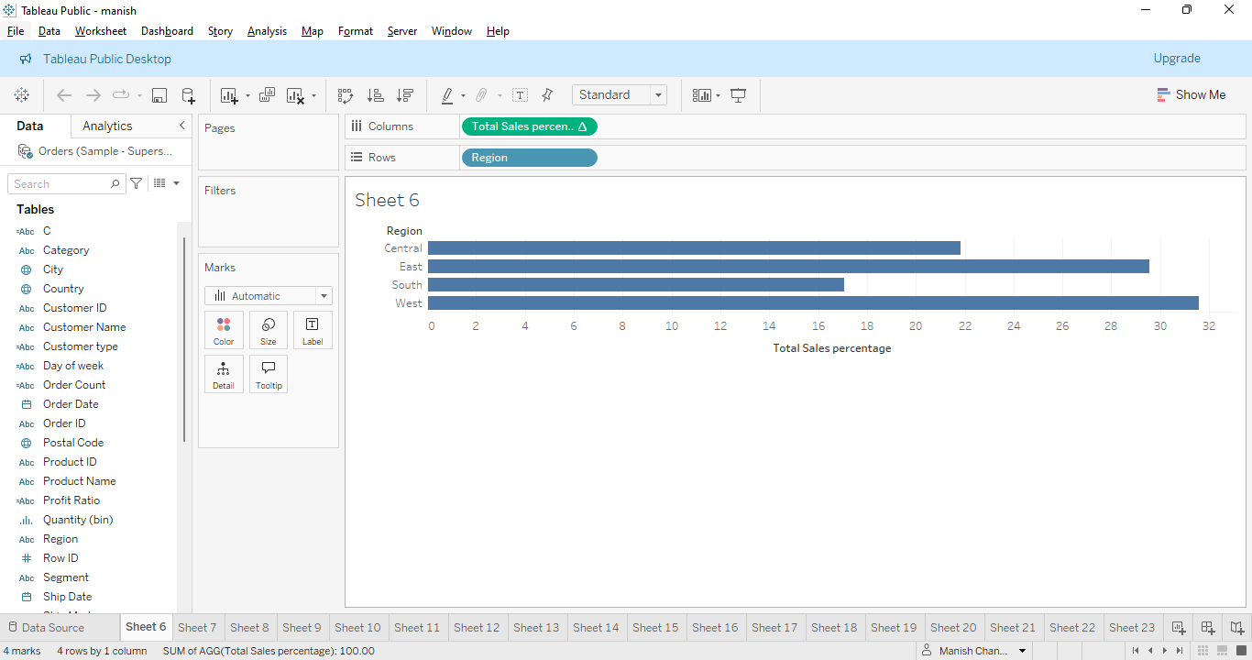

Chart type- Horizontal bar chart

Explanation- This chart is showing the percentage contribution of each region to the overall sales. Chart is having relation between region and total sales percentage. Bar are showing the information, south is lowest and west is highest. This chart can be depicted using other charts.

10.Can we visualise the profit margins associated with different shipping modes and customer segments?

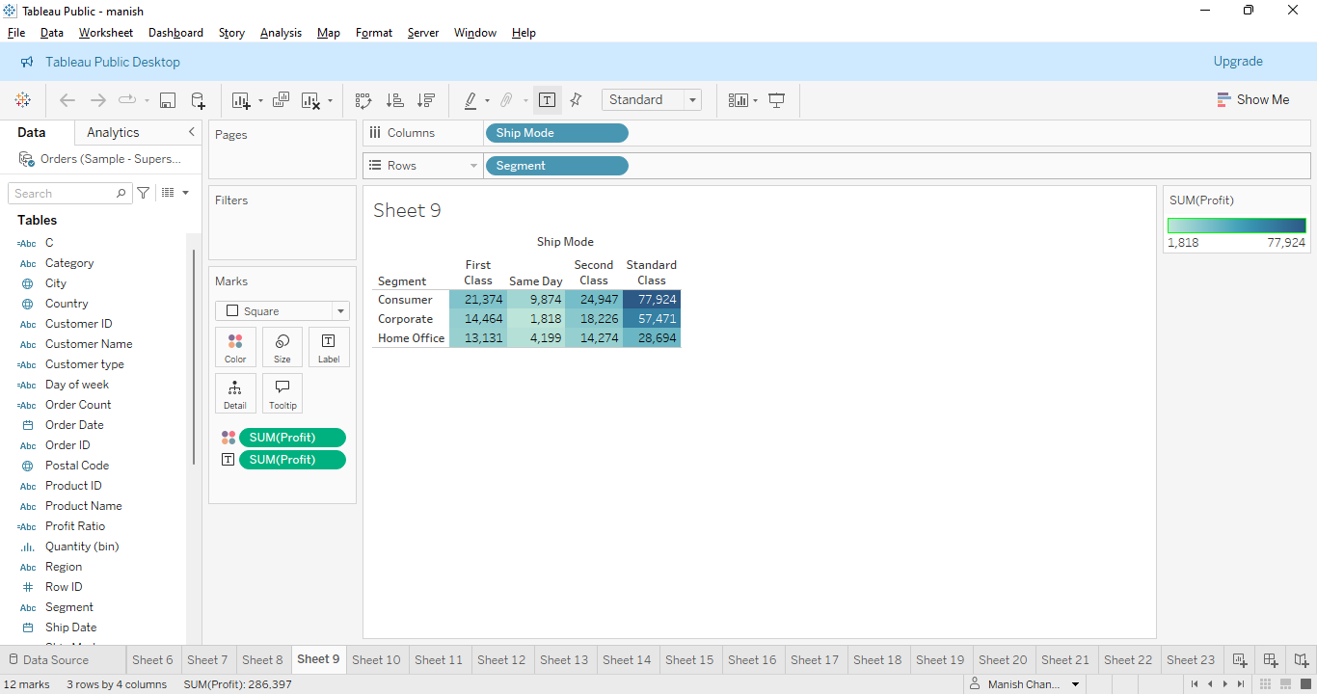

Explanation- We have visualised the profit margins associated with different shipping modes and customer segments. This chart depicts the relation between segment and ship mode. Segments are consumer etc and ship mode are First class, second day, second class etc. this Chart shows digits information and is easily understandable.

11.How long does it take to process orders for different product categories?

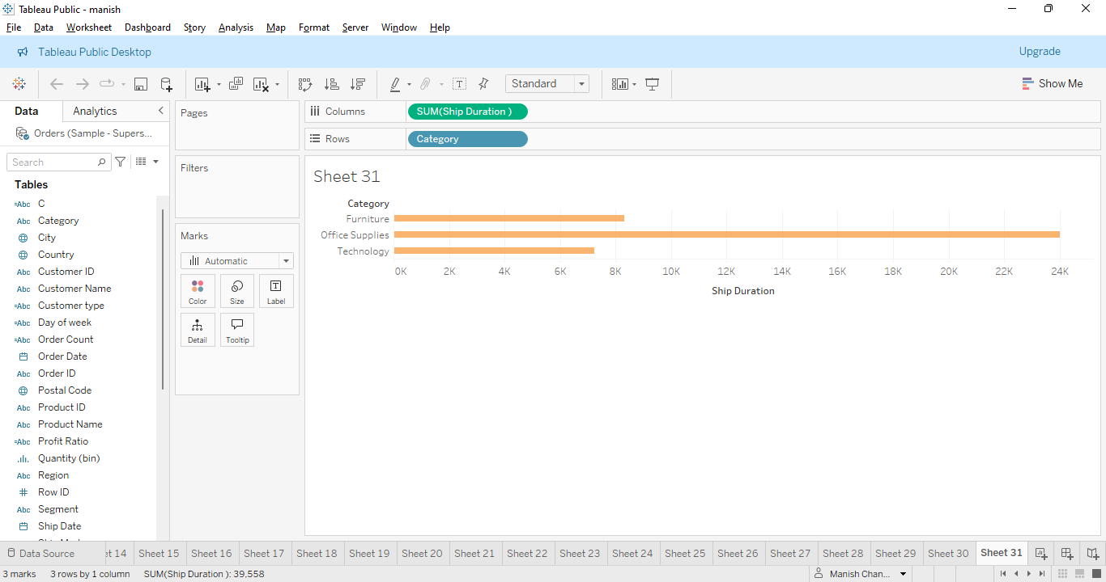

Chart type - Horizontal bar chart

Explanation- This chart shows the relation between Category and Ship Duration.

Here office supplies are the highest duration and technology has the lowest duration.

Again this can be depicted using line chart also. Thus the chart depicts insightful information.

12.How do discounts affect overall profit?

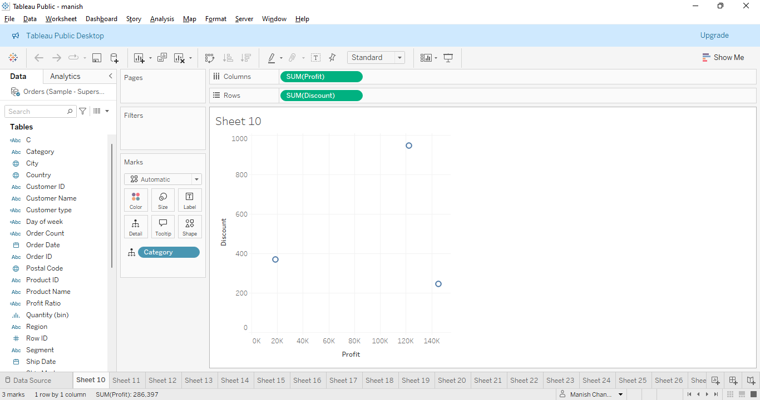

Chart type- Scatter plot

Explanation- This scatter plot shows discount relation with profit using scatter dots. X-axis represents the Profit and y-axis represents the discount here. Different dots shows different insights. Scatter plot is suitable to provide meaningful and insightful information.

13. Can we visualise the relationship between product sales and profitability for different product categories?

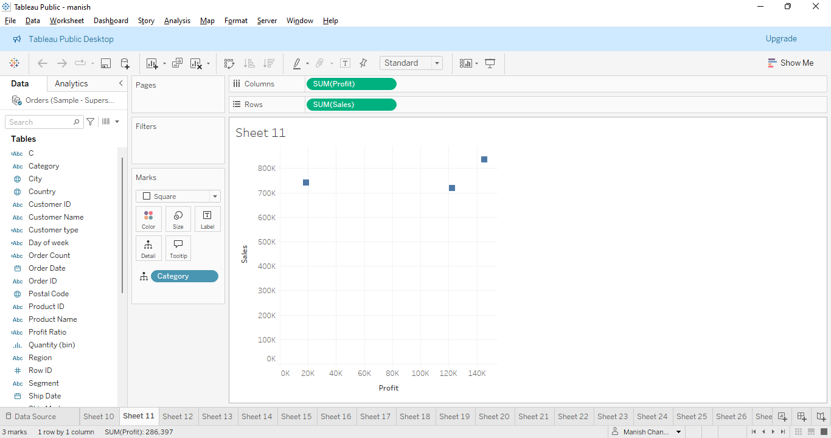

Chart type- Scatter plot

Explanation- This scatter plot shows the relationship between product sales and profitability

For different categories. X-axis shows profit and y-axis shows sales. Different dots are showing different insights. This is one of the charts which depicts meaningful visualisation and information. Bar chart is one of the alternative for it.

14.What is the distribution of order quantities for products in the dataset?

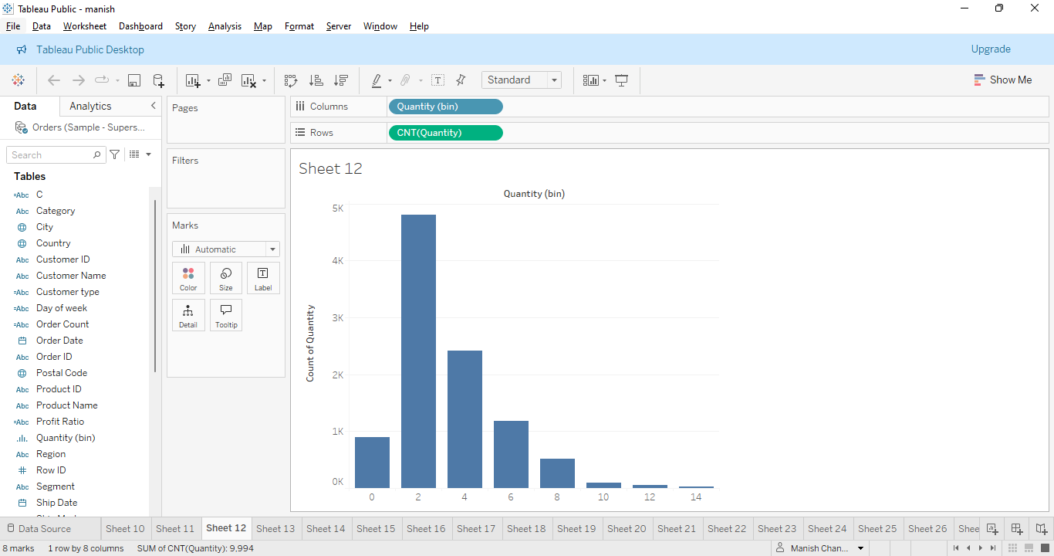

Chart type- Bar chart

Explanation- This chart shows the order quantities for the product in the dataset. X-axis shows count of quantity and y-axis shows quantity(bin). Each bar is showing different count for quantities. Bar chart is suitable for this visualisation. It will play important role for gettinge meaningful insights.

15.How do the profit distributions vary across different product categories?

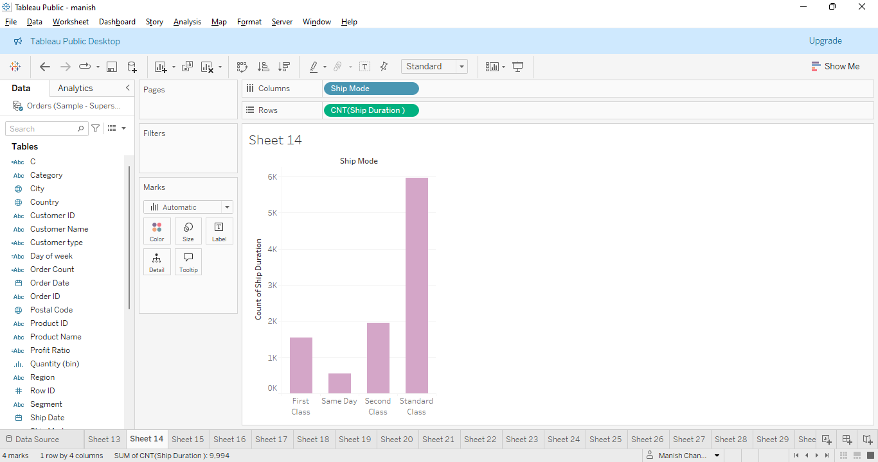

16.How do the profit distributions vary across different product categories?

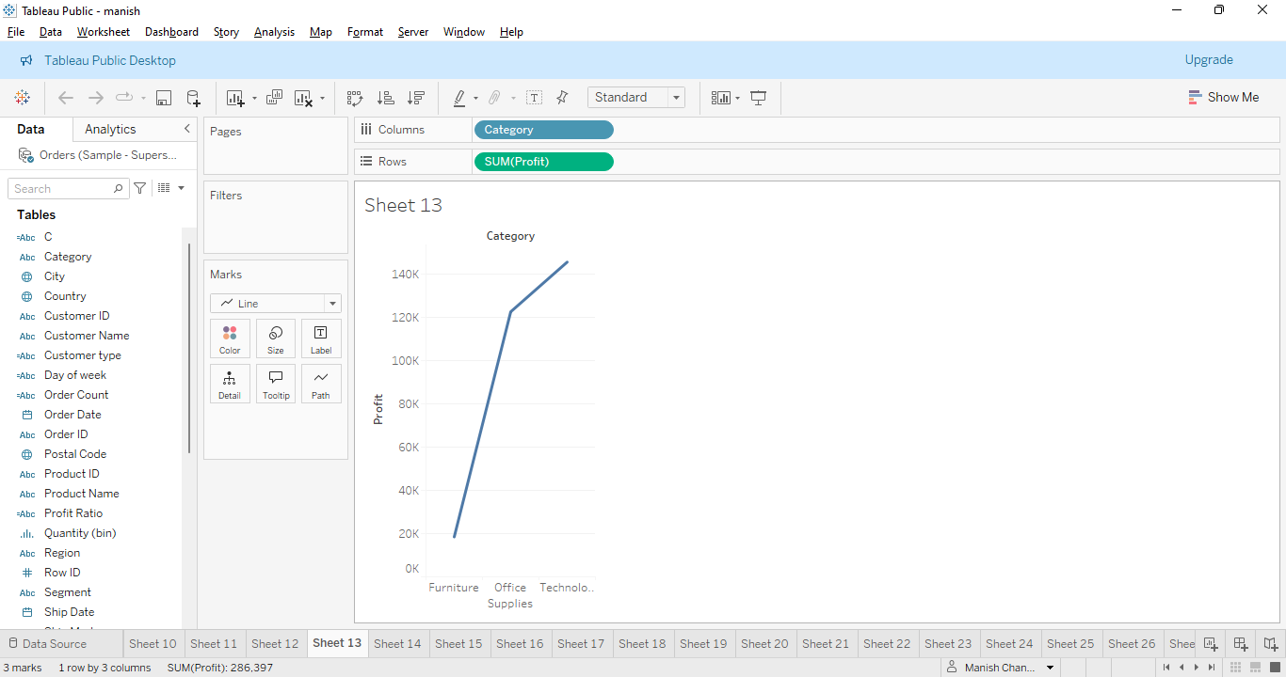

Chart type-Line Chart

Explanation- This chart shows the distributions across different product categories. X-axis shows supplies and y-axis shows Profit and categorise also. Line trends show the outcome information for it, for instance Furniture is the lowest. Other charts may be suitable for such analysis.

Can we compare the shipping time distributions for different shipping modes?s

17.What is the monthly trend in the number of orders shipped?

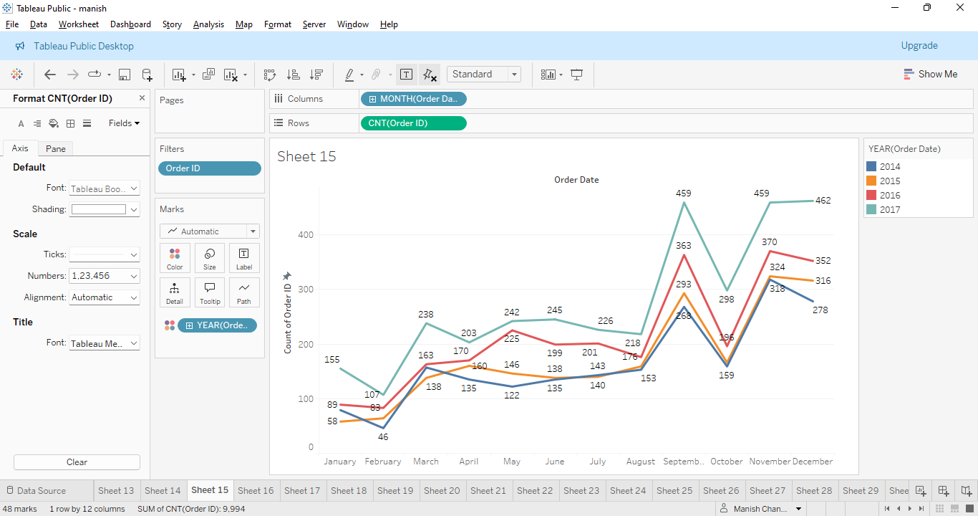

Chart type-Line chart

Explanation- This chart shows the monthly trend in the number of orders shipped. X-axis shows Count of orders and y-axis shows Order date. We have 4 trend lines here. Each one carries different colours. Trend lines may be a little bit confusing so digits insights have been shown here. I think that this is the best and easiest to understand chart and full of useful insights.

18.How do different customer segment perform in terms of sales and discount rates?

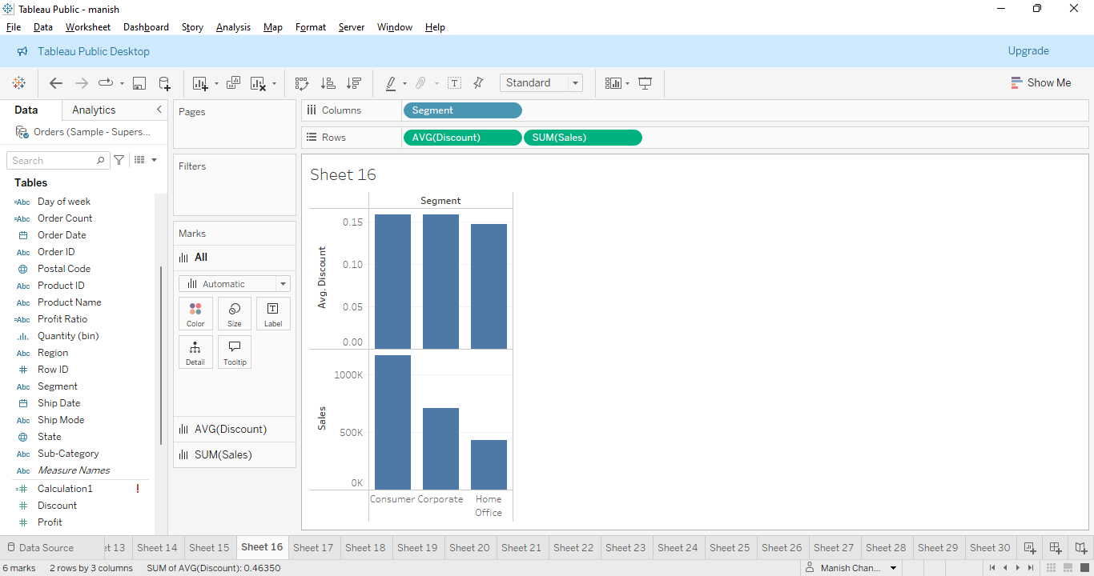Chart type- bar chart

Explanation- we have visualised the different customer segments performing in terms of sales and discount rates. X-axis shows sales and avg of discount and y-axis shows the segments. Each bar is showing meaningful and easy to understand insights. Other graphs like line graph may be suitable for it to get insights.

19. What are the sales and profit trends across different product subcategories and regions in the Superstore dataset?

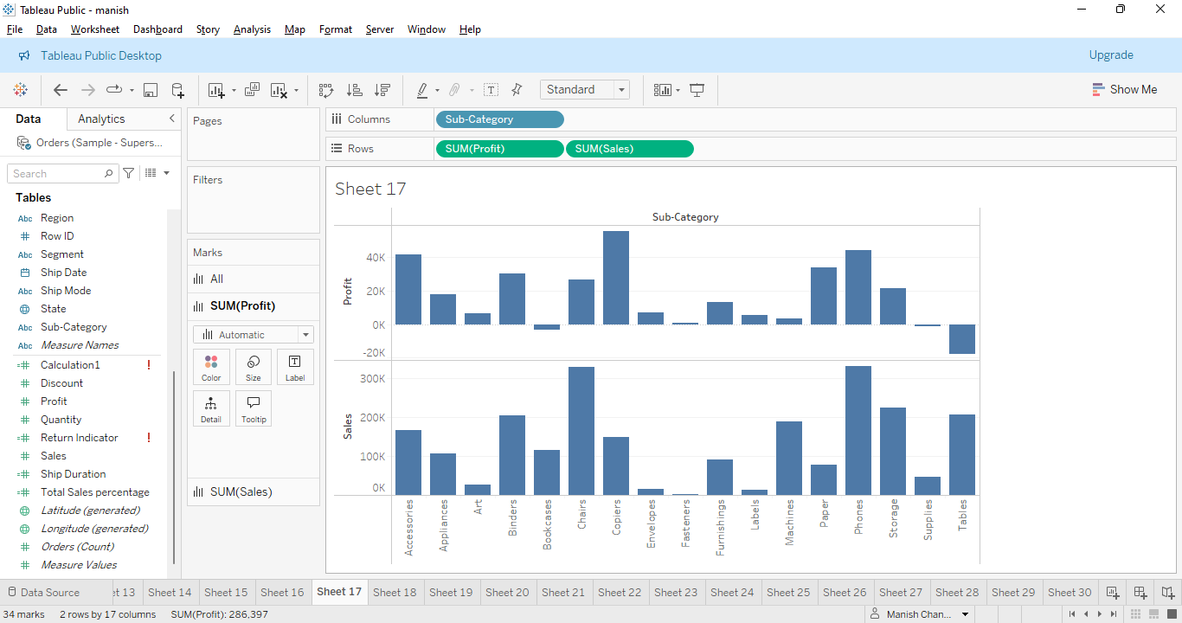

Chart type-bar chart

Explanation-

We have visualised the sales and profit trends across different product subcategories and regions in the Superstore dataset. X-axis shows sales and profit(2 categories).and y-axis shows the subcategories. We can clearly see the insightful information of all the bars from lowest to highest. This can be one of the best chart or full of insightful information for this chart.

20.What is the average delivery duration for different regions and ship modes?

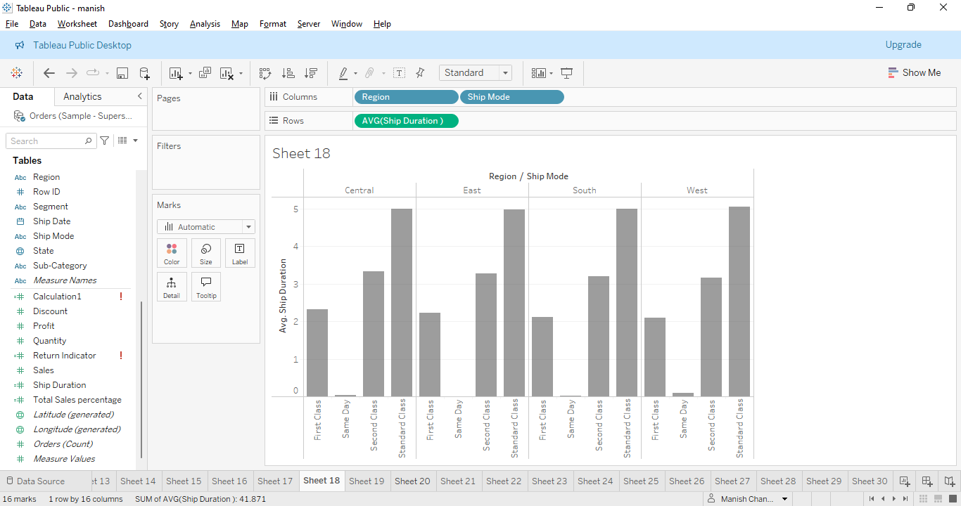

Chart type-bar chart

Explanation-

This chart shows the average delivery duration for different regions and ship modes.

X-axis shows region and ship mode. Y-axis shows Avg of ship duration. Region like Central, East,South,West are depicting the insightful information zonal wise. Particular regions under ship mode are showing the easy to understand insights. This will play a crucial role in further analysis.

21.How has the average order quantity changed over the years for various product categories?

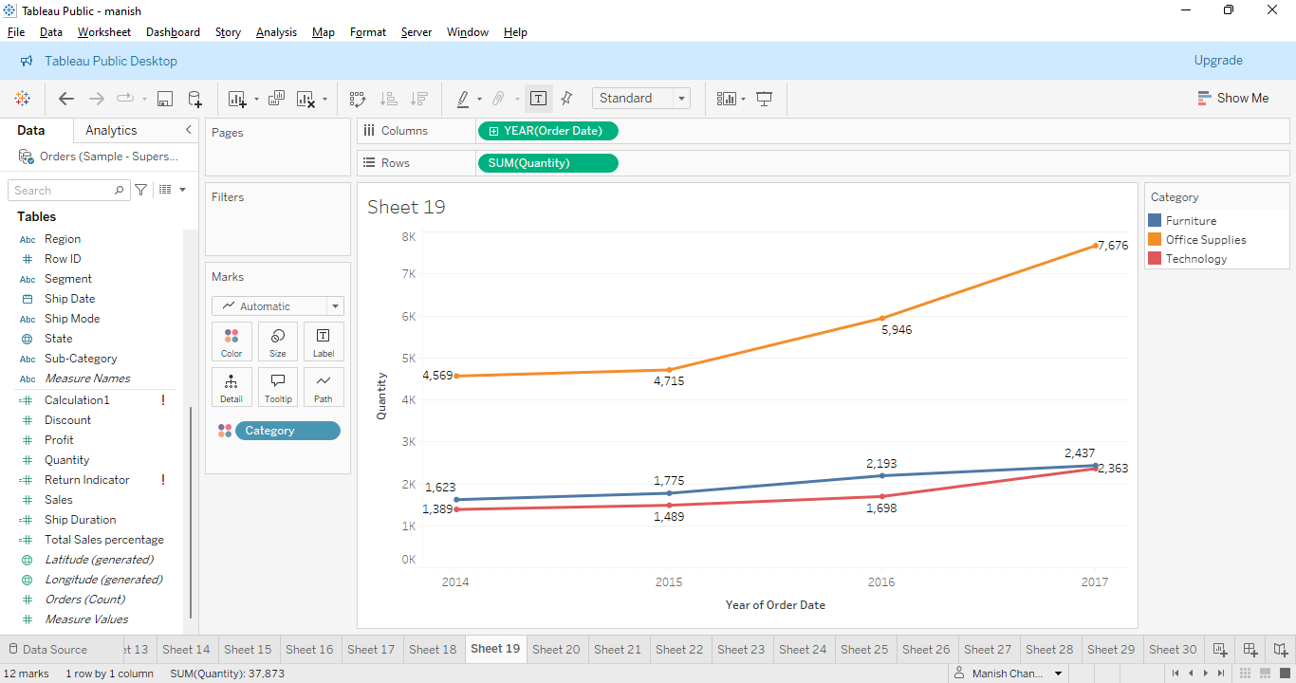

Chart type-Line chart

Explanation- We have visualised how the average order quantity has changed over the years for various product categories. X-axis shows the Year of Order Date and y-axis shows the Quantity. Particular points in line chart are showing the outcome. For the visualisation we have shown the digits for the particular points. 3 lines showing the outcome. It may be a better choice to choose such a chart for the clear insights and information. Colour categories have been defined in the chart also.

22.Can we visualise the correlation between discount rates and order quantities for

different customer segments?

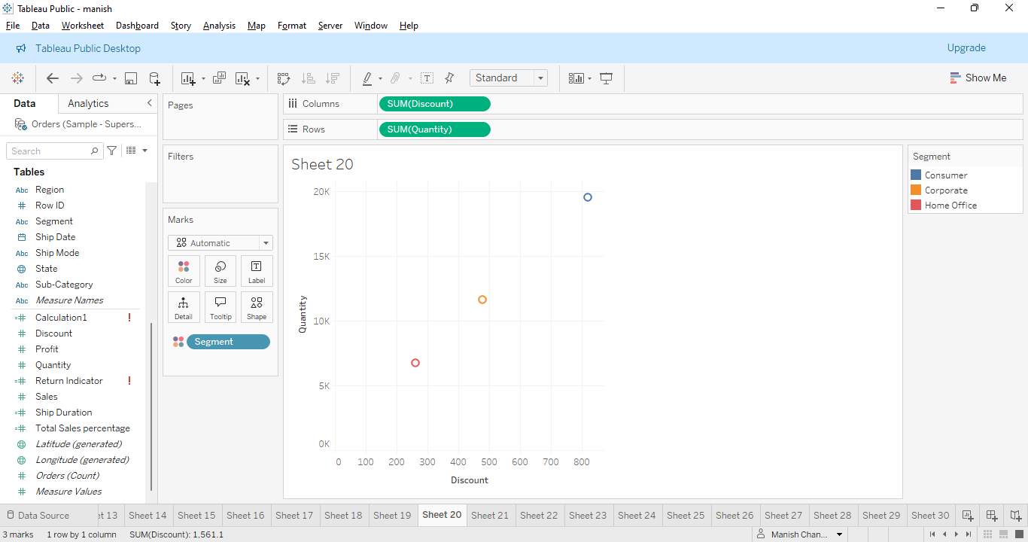

Chart type-Scatter plot

Explanation- we have visualised the correlation between discount rates and order quantities for different customer segments. X-axis is showing the discount and y-axis is showing quality and we will visualise it through the segment perspective because that is our outcome. Bar plot can be another option for it to depict the visualisation.

23.What is the proportion of orders returned in each region within the Superstore dataset?

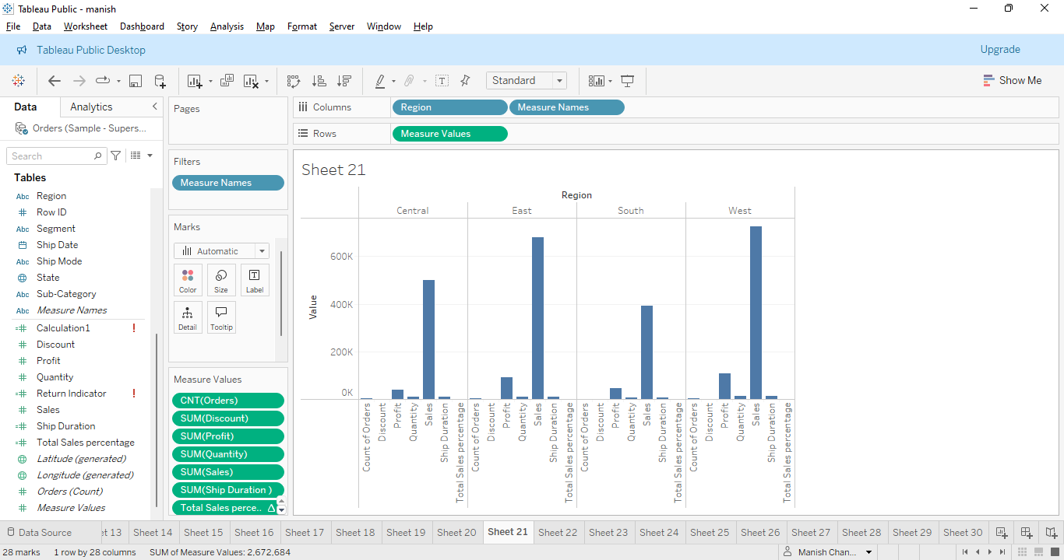

Chart type- bar chart

Explanation- we have visualised what is the proportion of orders returned in each region within the Superstore dataset. X-axis has their particular region like central,east etc and names as well. Y-axis is showing the values and it will be visualised through fetching values from the mark card and visualisation is very clear and gives useful information.

24.Can you compare the profit of different products for different subcategories?

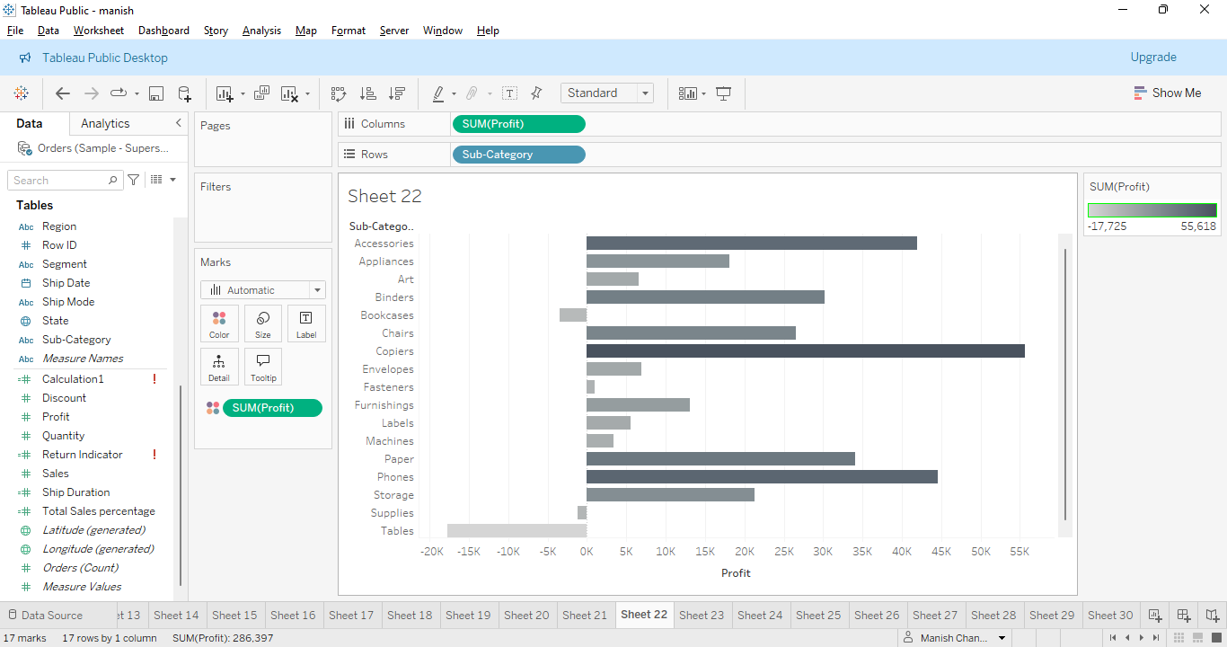

Chart type- Horizontal bar chart

Explanation- we have visualised the profit of different products for different subcategories. In order to serve the purpose x-axis shows the profit and y-axis shows the subcategories. Bars have been provided with different colours for respective identification.

It will be analysed through the sum of the profit and visualisation is absolutely clear which is useful for serving the purpose. It is the best choice here to choose such a chart.

25.Which shipping mode is the most commonly used in the Sample Superstore dataset?

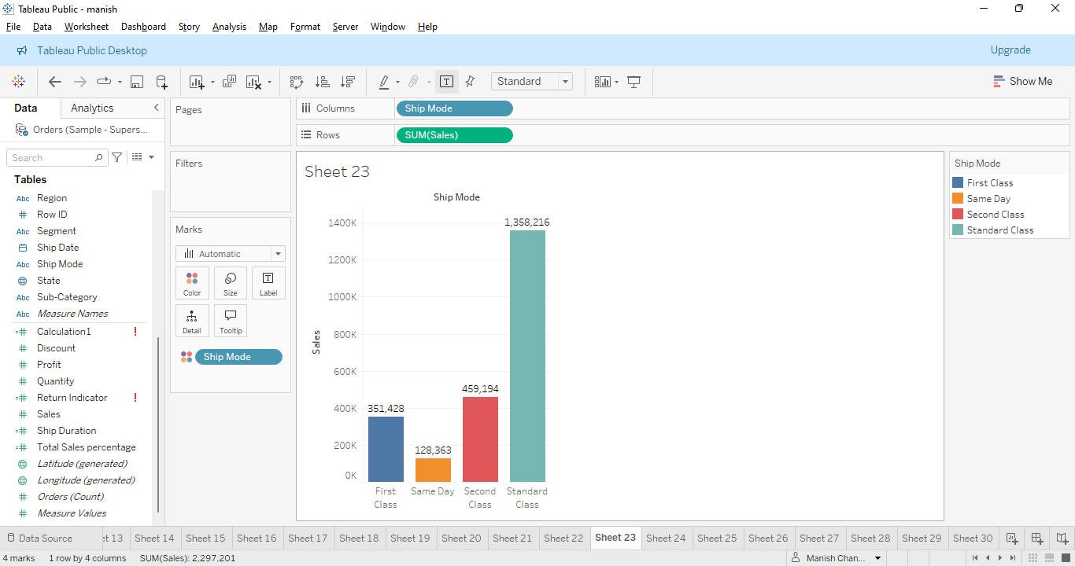

Chart type-Bar chart

Explanation- We have visualised that Which shipping mode is the most commonly used in the Sample Superstore dataset. X-axis is showing shipping mode categories for example first class, standard class etc and y-axis is showing sales. In this visualisation exact numbers are also shown. Now it is easy to understand the visualisation. Different bars show the different colors. As per the graph standard class is high. It is best visualisation for it.

26. How does the sales performance of different regions evolve throughout the quarters of a year?

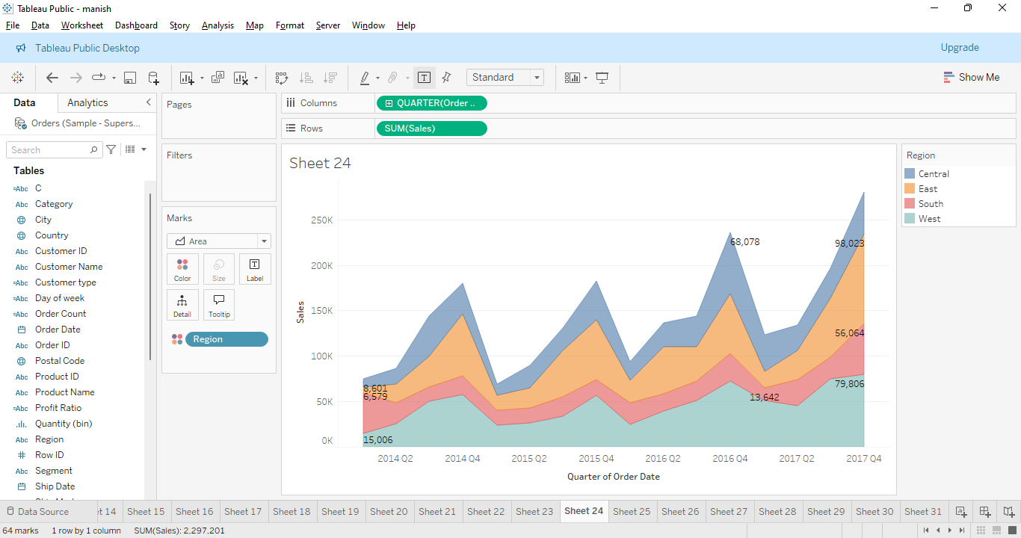

Chart type-Area chart

Explanation-It is visualised here that How does the sales performance of different regions evolve throughout the quarters of a year. X-axis is showing the order of the year and y-axis is showing the sales and it is being visualised through region perspective in mark card. Chart is designed with different colours and to avoid unnecessary confusion values are also shown. The area chart is absolutely a good chart for it.

27.What is the distribution of order priorities across different product categories?

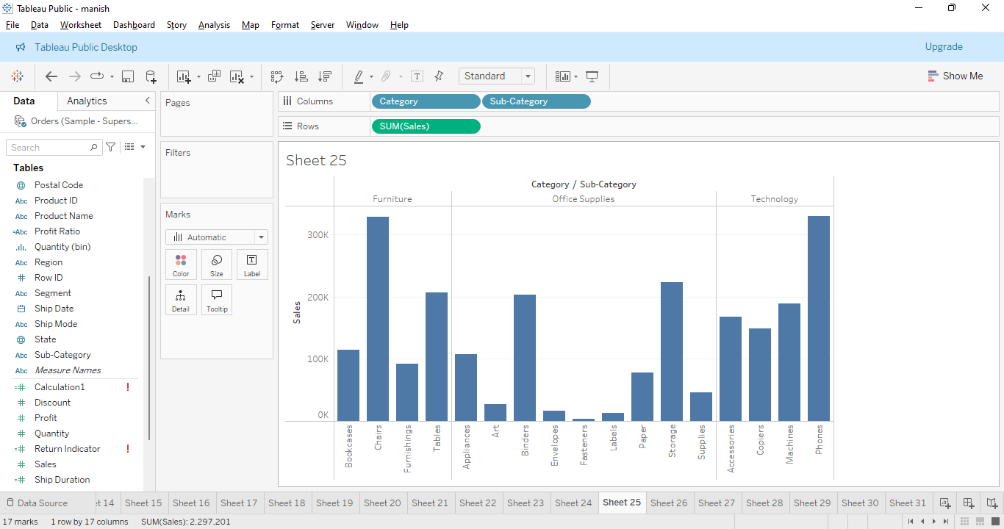

Chart type- bar chart

Explanation- we have visualised what is the distribution of order priorities across different product categories. So we have 2 product categories one is category and second is sub category, will be on x-axis. Sales will be in the y-axis. Furniture, office supplies and office category are showing their respective subcategories and their respective values. Bar chart is clearly showing the visualisation for it and generating useful insights.

28.What is the relationship between discounts and sales?

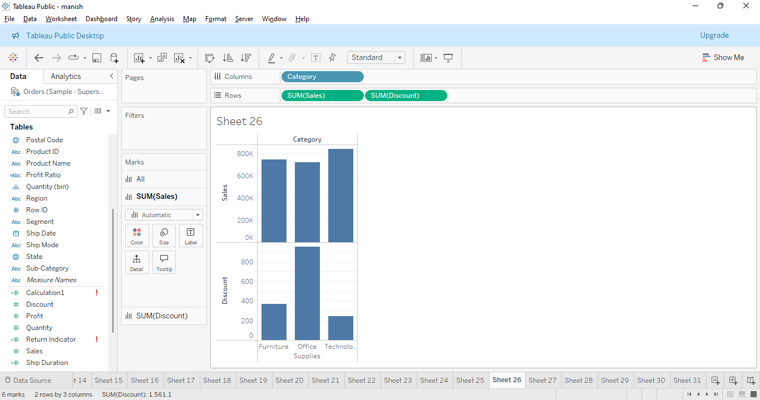

Chart type- bar chart

Explanation- we have visualised the relationship between discounts and sales. X-axis is showing the discount and sales. Y-axis is showing the category and supplies. Each bar is showing the relation and particular values also. This is the best visualisation to serve the purpose.

29.How does the average order value differ between repeat customers and new customers?

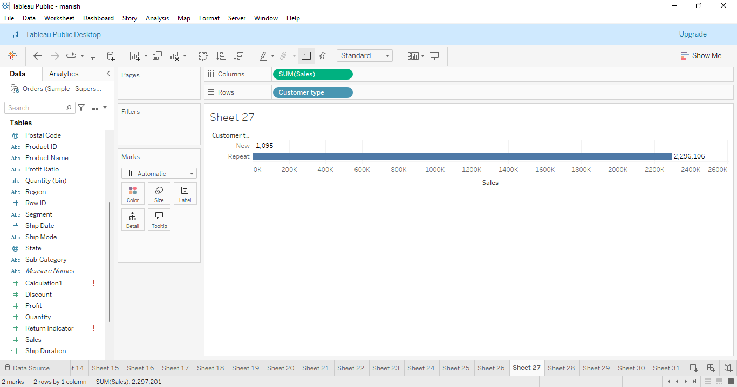

Chart type- Bar chart

Explanation- this chart shows how the average order value differs between repeat customers and new customers. Sales are being compared with the type of customers like new and repeating customers and it is obvious that repeating customers are more than new. Values are being shown here in order to avoid unnecessary confusion.

30.What is the geographical distribution of returns and its impact on overall profitability?

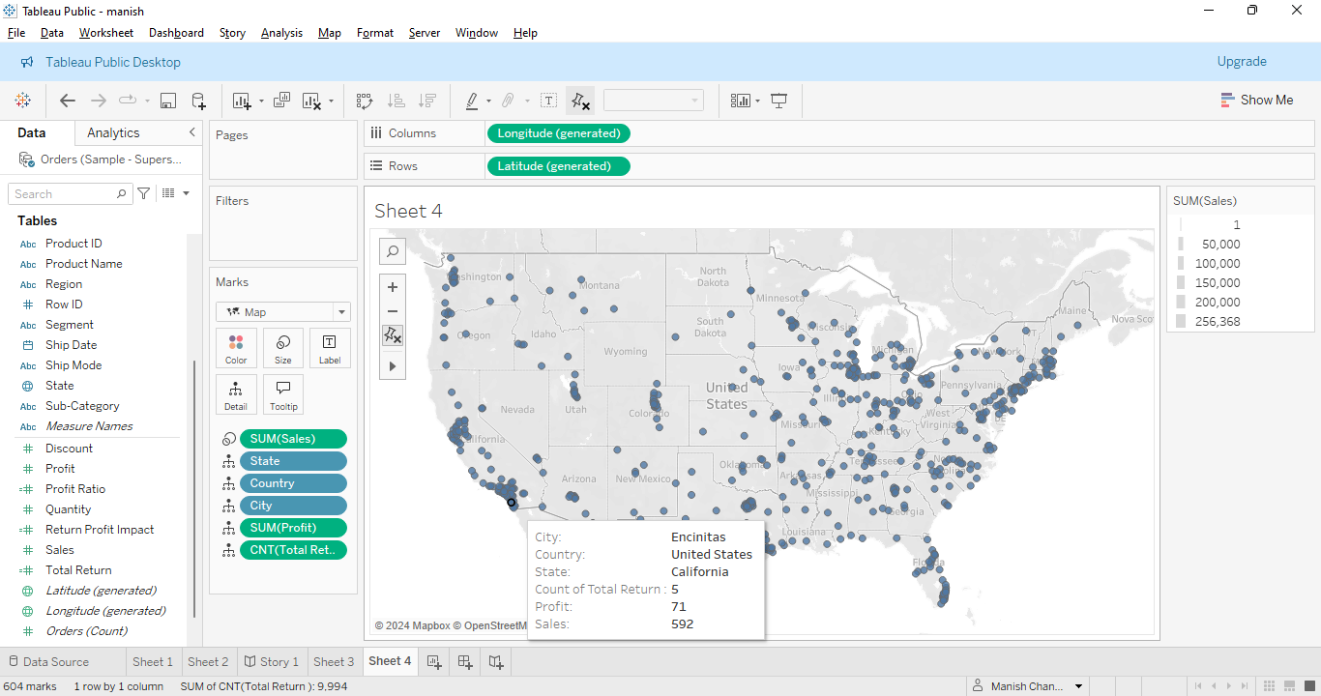

Chart type- Choropleth Map

Explanation- this map is an excellent tool for distribution and spotting patterns. This graph shows the geographical distribution of returns and its impact on overall profitability. This is visualised based on latitude and longitude and dots are showing all the state and cities. By clicking the dots we can get more information which is needed as per the question here. One dot has been clicked and it is showing the useful information which is required.